Company: Unlimited

Date: 1/26/20

Members: Kehan Meng, Linsong Li, Shixian Jing

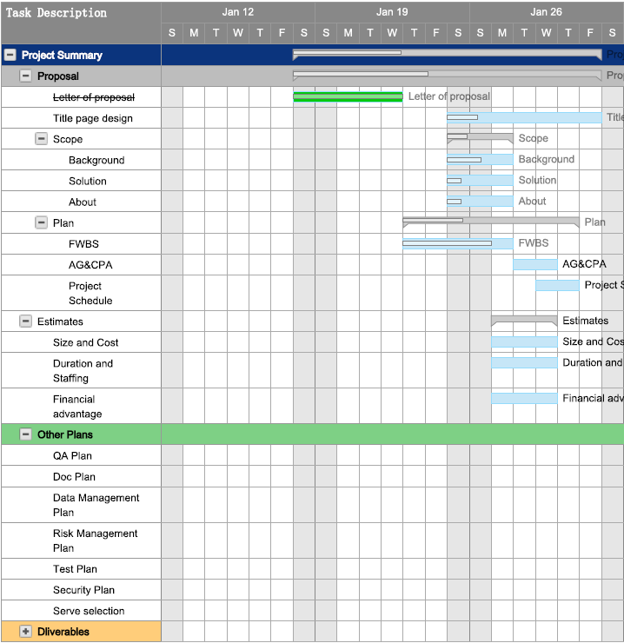

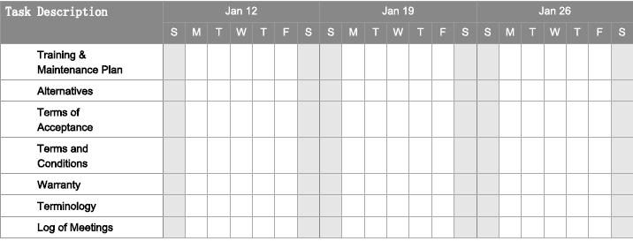

Linsong Li: FWBS and Estimates

Shixian Jing: Background introduction, market research, solution and about company. He also works on company logo design and title page design.

Kehan Meng: Project schedule and AG&CPA when FWBS is finalized.